Anton Reunovs, Carlos Schaap García, Cosmin Buzic, Felix Anghel and Stefan Bryda
Drunken sailor Group 1
Drunken Sailor Design Document

Contenido
Diagrams 2
Architecture Diagram 2
Flowchart Diagram 3
Use Case Diagram 4
App Design Iterations 5
Burger Menu 5
Compass 6
Iteration 1 6
Iteration 2 7
Iteration 3 8
Iteration 4 9
Radar 10
Iteration 1 10
Iteration 2 11
Iteration 3 12
Geiger Counter 13
Iteration 1 13
Iteration 2 14
Iteration 3 15

Diagrams
This chapter explains the main structure and behaviour of the Drunken Sailor app using different UML and process diagrams. The diagrams show how the app is built, how the user moves through the app, and which external services are needed, such as GPS, sensors, vibration, and Firebase.

Architecture Diagram
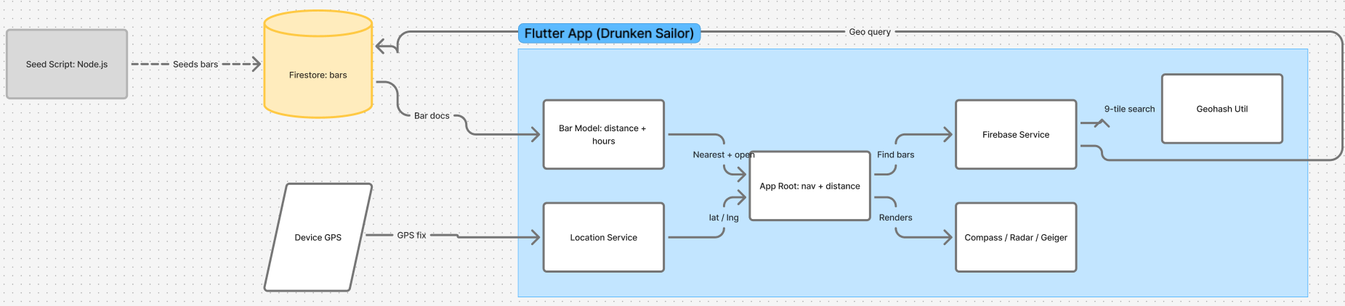
The architecture diagram shows the main technical parts of the application and how they communicate with each other. The user interacts with the Flutter interface, which contains the compass, radar, and Geiger counter views. These views use services for location, heading, vibration, and bar data. The bar data is loaded from Firebase Firestore and can also be cached so the app can still work better when the connection is unstable.

Flowchart Diagram
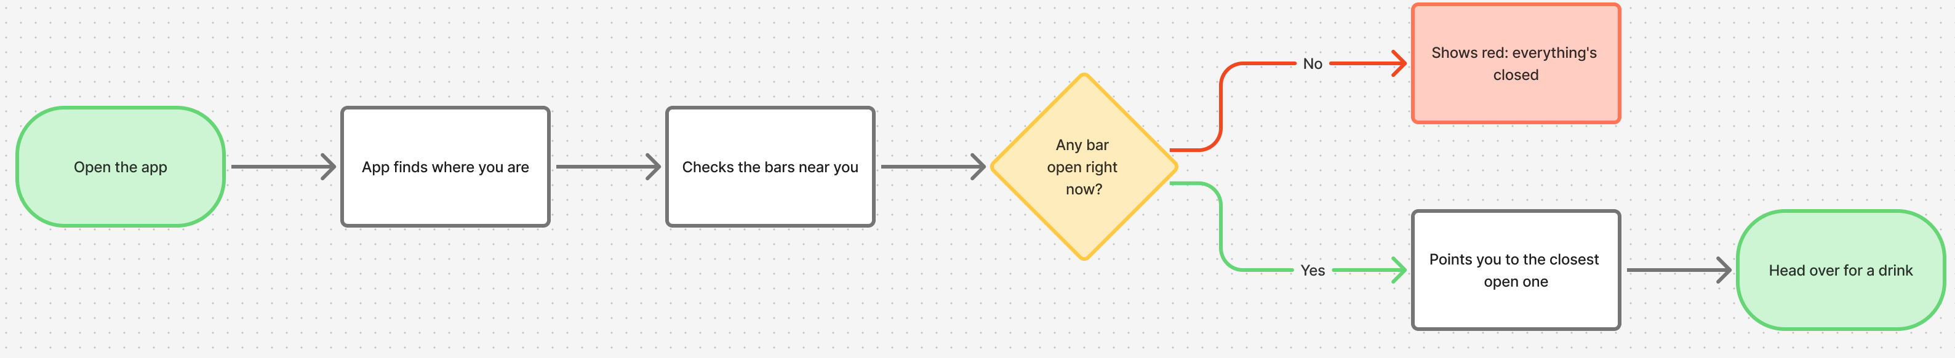
The flowchart diagram shows the main flow of the app from startup to finding a bar. First, the app starts and asks for location permission. If permission is accepted, the app gets the user’s location and loads nearby bar data. The app then checks which bars are open and shows the nearest open bar. If no open bar is found, it shows the nearest closed bar instead.

Use Case Diagram
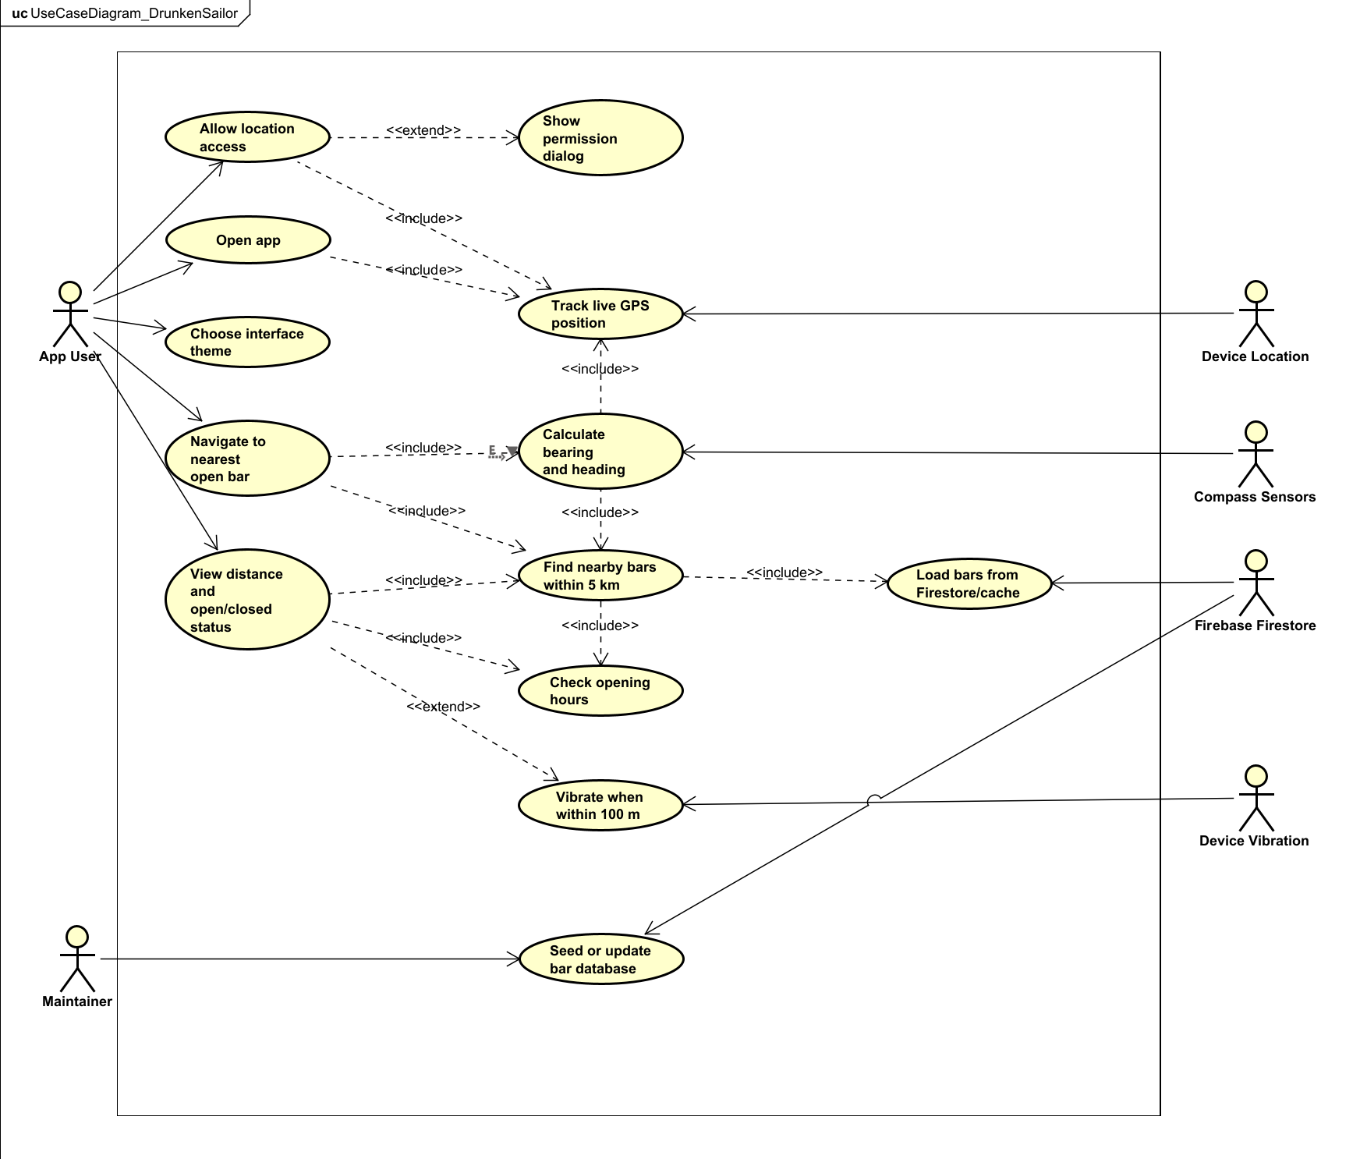
The use case diagram shows what the user can do with the app, and which external systems are involved. The main user can open the app, allow location access, choose between the compass, radar, and Geiger counter views, and navigate to the nearest open bar. The app also communicates with device services such as GPS, compass sensors, vibration, and Firebase Firestore. The maintainer can update or seed the bar database.

App Design Iterations
This chapter shows how the visual design of the app changed over time. Each iteration improved the interface by making it more themed, more readable, and more suitable for the final concept of the app. The designs started simple and became more polished with stronger visual styles for each mode.

Burger Menu
The burger menu gives the user a simple way to switch between the main app views. It contains the Compass, Radar, and Geiger Counter options, as well as planned options such as Map and Blacklist. This menu helps keep the main screen clean while still allowing navigation to the different app modes.

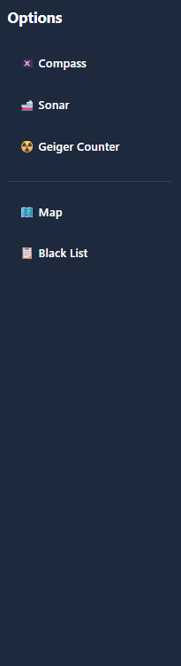

Compass
The compass view is designed to point the user toward the nearest open bar. It uses the phone’s location and compass heading to calculate the direction of the target. The different iterations show how the compass changed from a simple wireframe into a more themed pirate-style interface.

Iteration 1
The first compass iteration is a basic wireframe. It shows the main layout of the screen, including the compass, destination information, distance, and navigation buttons. The focus of this version was functionality and structure rather than visual design.

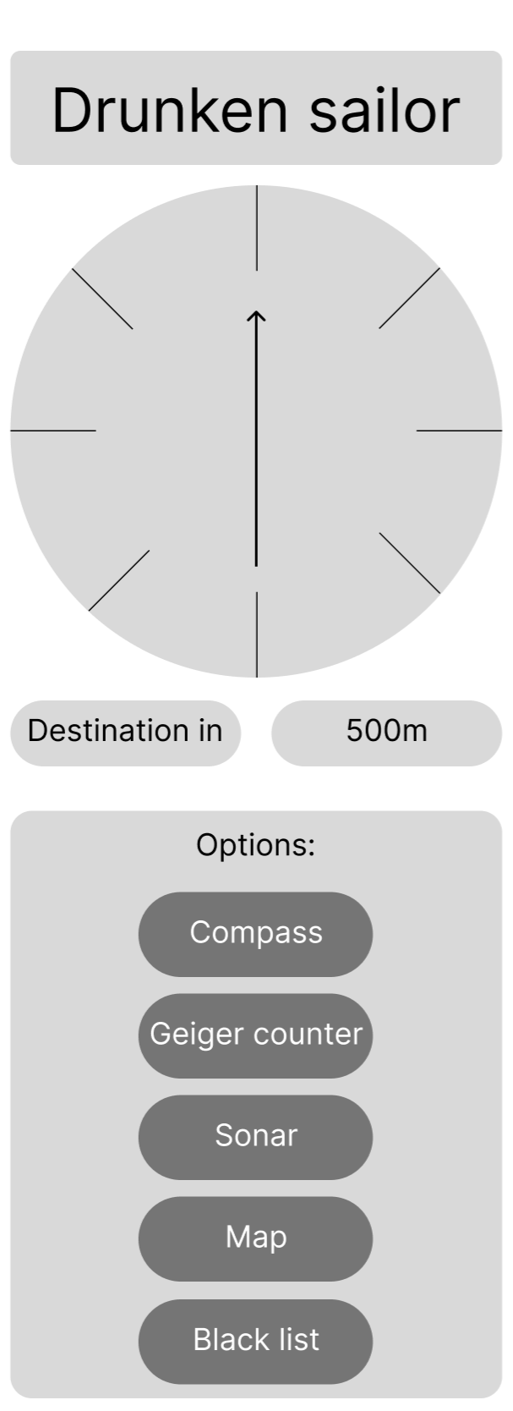

Iteration 2
The second compass iteration adds a darker mobile interface and begins to look more like the final app. It includes a top navigation bar, a distance indicator, and a compass in the centre of the screen. This version improves the layout and makes it feel more like an actual mobile application.

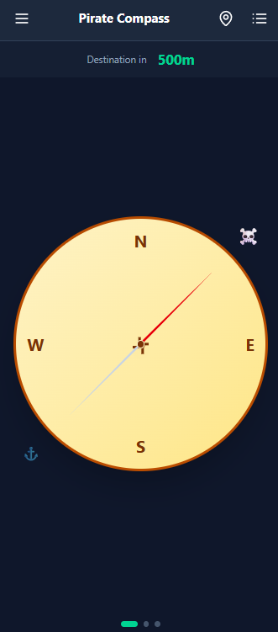

Iteration 3
The third compass iteration adds a pirate-inspired visual style. The wooden background gives the screen more personality and connects the design better to the “Drunken Sailor” theme. The compass remains the main focus of the screen.

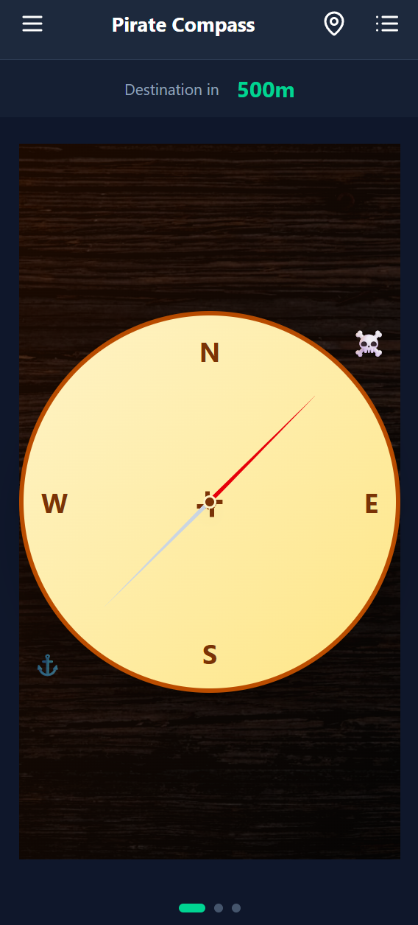

Iteration 4
The fourth compass iteration simplifies and improves the final visual style. The compass becomes cleaner and easier to read, while still keeping the pirate theme through colours and details. This version feels more polished and usable than the earlier designs.

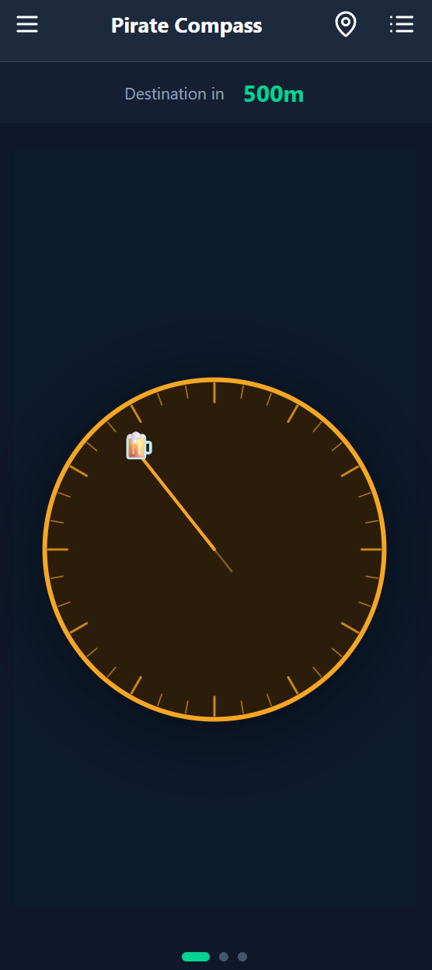

Radar
The radar view gives the user another way to see nearby bars. Instead of pointing directly like a compass, it shows bars as points on a radar screen. This fits the submarine theme and gives the user a more visual overview of nearby locations.

Iteration 1
The first radar iteration is a simple wireframe. It shows the basic idea of a radar display with nearby points and the same general navigation structure as the rest of the app. This version focuses on the concept rather than detailed styling.

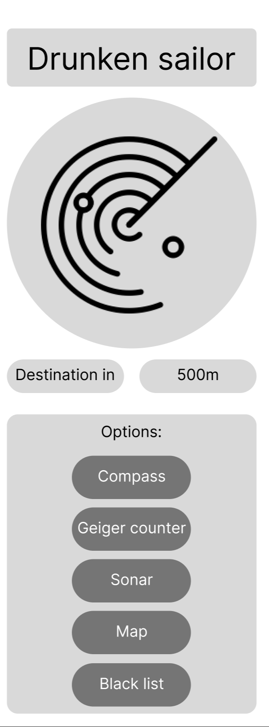

Iteration 2
The second radar iteration adds the darker app interface and green radar visuals. The bars are shown as dots on the radar, making it easier to understand their relative position. This version already matches the submarine theme more clearly.

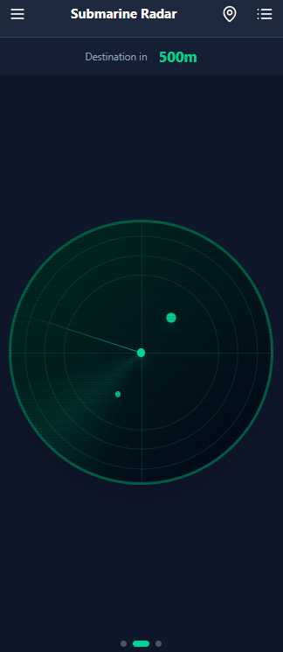

Iteration 3
The third radar iteration improves the visual atmosphere with a stronger underwater style. The background and radar effects make the screen feel more immersive while keeping the radar readable. This version is closer to the final intended design.

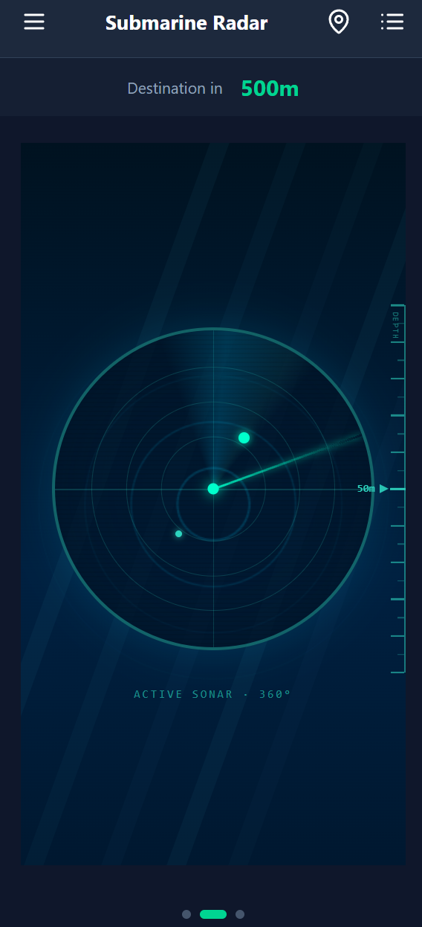

Geiger Counter
The Geiger counter view uses a nuclear/radiation theme to show how close the user is to a bar. Instead of only showing direction, it focuses on intensity and distance. The app can also use vibration when the user gets close to the target.

Iteration 1
The first Geiger counter iteration is a basic wireframe. It shows a simple meter, destination information, distance, and navigation buttons. The goal was to plan the layout before adding the nuclear visual theme.

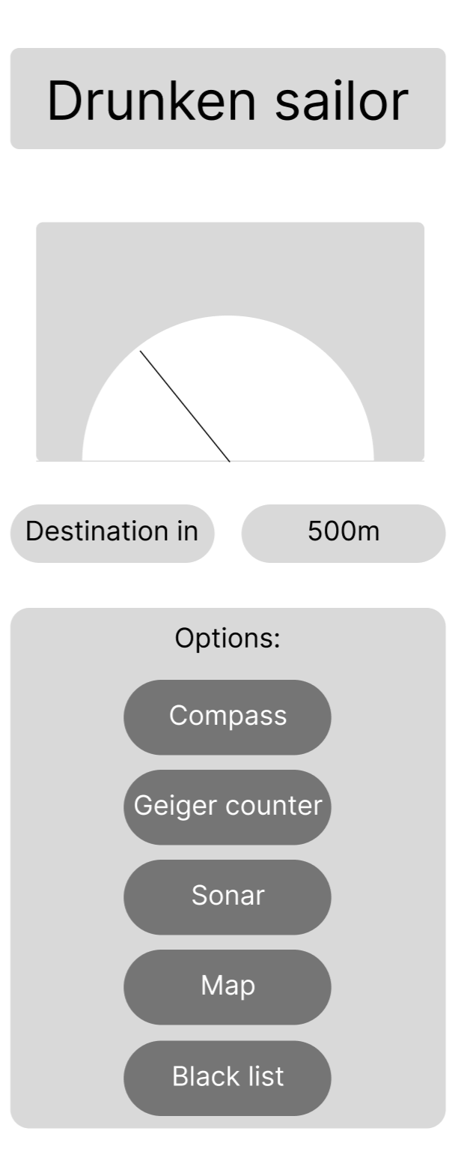

Iteration 2
The second Geiger counter iteration introduces the dark interface and a radiation meter style. It includes a clear distance indicator and a strong red visual focus, which makes the view feel different from the compass and radar screens.

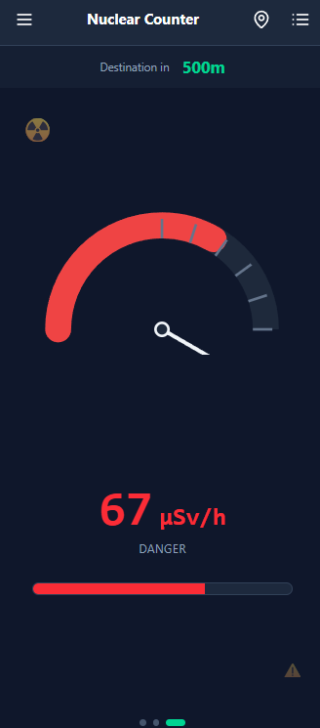

Iteration 3
The third Geiger counter iteration adds more nuclear-themed details, such as warning stripes and stronger colours. This makes the screen more distinctive and improves the connection between the design and the Geiger counter concept.

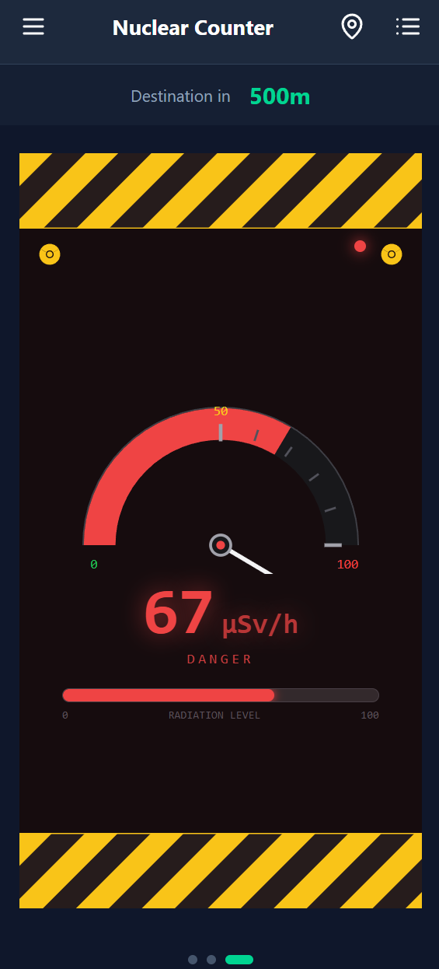

Map
The map offers a support for navigating streets to reach the destination as well as providing an overview of the closest bars.

